BM 538

Computational Neuroscience

Project:

Psychophysics

Experimentor:

Kerem Kurban

Submitted to:

Burak Güçlü

Sevgi Öztürk

Experiment Date:

6-20 Oct 2017

**Results**

The purpose of this experiment was to observe absolute and relative thresholds of White, Red ,Green and Blue pixels which were changing their intensities from 0 to 90 with respect to uint8 function. However, in the case of relative threshold, the minimum value was set to 50 units due to incomprehensibility of pixels below certain unit which may otherwise have biased the results. The difference of the left and right pixels in terms of intensity was set as -40:10:50 in which minus sign represents that the left side was brighter. The sample size of this study is 2 at the moment. Both of the subjects performed the experiment in a dark room after an initial dark adaptation phase of min 10 minutes. The experiment was conducted on 17.3 inch LCD computer screen with brightness set to minimum on battery condition.

In the case of absolute thresholds, the sensitivity of both users to colors in order, from high to low, was green-white-red-blue which can be seen in *figure 1*. With rod cells having maximum absorbance at 510 nm (green) , it is as expected that green sensitivity is highest. However the data from the second subject was lost while saving its absolute threshold image due to a crash in Matlab. Notwithstanding this unfortunate event, we could have a chance to discuss this part of the result with the subject therefore it was comparable and mostly similar with the other subject. One difference between the two subjects was, the proximity between foveal and peripheral absolute thresholds of white stimulus was nearly on top of each other in one subject (data not shown), whereas the other (seen in fig 1) had a wider distance between foveal and peripheral absolute thresholds. Both subjects reported that blue stimulus was the hardest to detect, then the red one. One subject showed better peripheral sensitivity to white stimulus while the other was better in foveal. Since rod cells are distributed at peripheral region of the retina, it is expected that peripheral sensitivity for them would be higher. The reason for this variance could be arisen from minor differences in experiment set-up as well as changing motivation and differences of eye healthiness of the subjects. The threshold of white stimulus being between red,green and blue is expected since white is composed of these 3 colors set to same value.

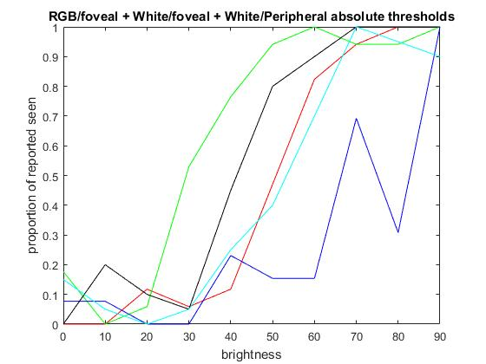

Figure 1 : Absolute thresholds of foveal RGB, foveal white(black) and peripheral white(cyan) stimuli. Arrows indicate absolute thresholds on the X axis.

Unfortunately , the data was lost for the second part of the experiment for the second subject before an interpretation or saving. Therefore, based on the result of the first subject we can state that there is a high variation of right preference among relative differences of intensities. From *figure 2,*it can be seen that after difference in brightness starts to favor right side, there is a increased trend in right-side selection in all cases. However, when left side is brighter, there seems to be a discrete distribution of right-side preference in -10 and -30 cases for all colors. So there must be a factor affecting the subject’s decision making which make him think of the right side is brighter. The reason can not be a same distribution of epochs in all colors so the difference change could have have an effect on the result, because the epochs were randomized differently for each set. That being said, Weber defined **lower difference threshold (ldt)** is reached whent the comparison stimulus is judged to be more intense than the standard on 25% of trials, and for **upper difference** **threshold (udt)**, 75%.1 If we draw line at 0.25 and 0.75 respectively and without considering negative x values due to high variablility, it can be said that ldt falls 20-30 units region in x axis while udt falls between 30-40 region. The values corresponding to each threshold is given in *table 1.*

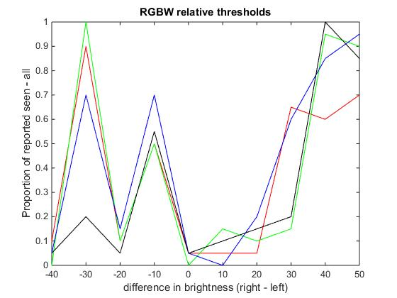

Figure 2: Relative threshold experiment results, ldt & udt values shown in x axis.The red udt is higher than 50.

Table 1: Abs. and relative thresholds (both lower and upper diff. thresholds) gathered from figure 2:

|  |  |  |  |  |
| --- | --- | --- | --- | --- |
|  | Red | Green | Blue | White fov/per |
| Abs. Threshold | 50 | 30 | 66 | 41 /52 |
| Relative ldt | 22 | 31 | 21 | 31 |
| Relative udt | - | 38 | 38 | 38 |

**Supplementary Material:**

Before nearly perfecting the experiment for relative thresholds, a slightly different experiment conducted first. In this experiment, the right side was also always changing, with both side having minimum brightness of 60. From *figure 3*, it can be seen that at -40 and 0 in terms of x axis, meaning left side was 40 units brighter in the former and in the latter both had the same intensity, there is a high correlation between RGBW stimuli in the favor of right side. In the 20-30 region there are also increased preferences in favor of right side although in a more diffused manner. Much more data and more fixed parameters are required in order to make correct assumptions from this part of the experiment. However it can be seen that there is a significant trend for the subject to choose right side when the intensities were the same.

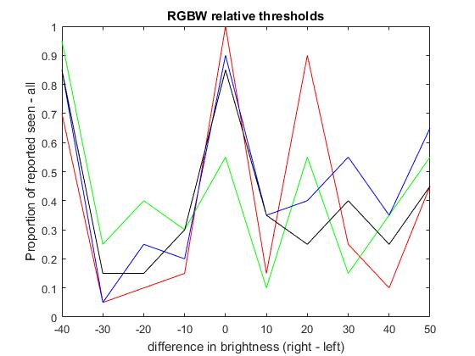

Figure 3 : The results of the relative threshold experiment with a right side having random brightness.

Update:

The same experiment with 20% rate of mock trials were performed and the results were obtained from a single subject with max computer luminance(*figure 4)* and minimum computer brightness (*figure 5)*. As can be seen from these figures, all colors have nearly perfect sigmoidal curves and the order of sensitivity is similar to that of *figure 1*. Moreover, as the luminance decreased, the curves shifted to the right due to higher luminance requirement from the screen. The detected signals are given below:

False alarm_normalized = 800 (normally 200) / 798 (198)

Correct rejection_normalized = 0 of 800 trials (normally 200) / 8 (2)

Detect = 440 of 800 trials / 364

Miss = 360 of 800 trials / 436

There seems to be some kind of programming error or massive subject bias to not reject any of false trials. In most of the experiments, it was thought that there was a problem with the code but at the last time, there was 2 trials correctly rejected for peripheral white test. Therefore, unless some complex issue was happenning, the subject kept missing correct rejection values.

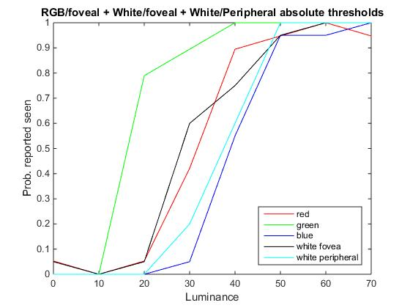

Figure 4: Absolute thresholds of foveal RGB, foveal white(black) and peripheral white(cyan) stimuli. This time with mock trials. The nearly perfect sigmoidal curves can be seen for all colors. (Max luminance)

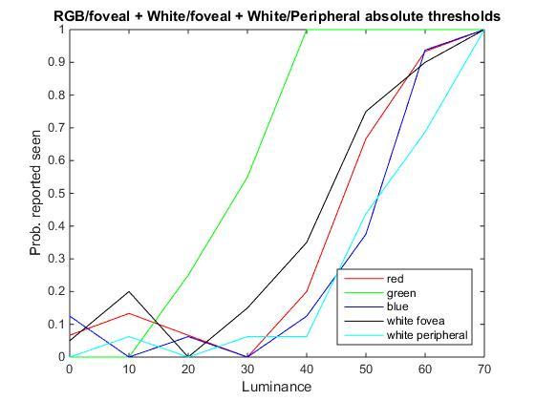

Figure 5: Absolute thresholds of foveal RGB, foveal white(black) and peripheral white(cyan) stimuli. This time with mock trials. The nearly perfect sigmoidal curves can be seen for all colors. (Min luminance)

References:

1. Sensation and Perception, Indiana University Purdue University Fort Wayne, 2101 E. Coliseum Blvd., Fort Wayne, IN 46805. (<http://users.ipfw.edu/abbott/120/thresholds.html>) (taken at 19 oct 2017)